**Chapter 3**

**RESEARCH DESIGN AND METHODOLOGY**

* 1. **System Design**
     1. **System Block Diagram**

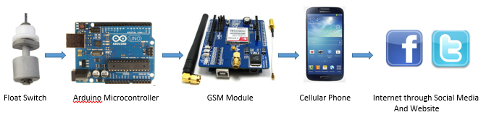

**Figure 3.1** System Block Diagram

The hardware design is split into parts. The first part is composed of the water level sensor, Arduino microcontroller development board and GSM Module. When the water level rises above the level where the float switch is mounted, the sensor will be triggered and the corresponding output signal will be fed into the microcontroller which directs the appropriate SMS message to the GSM module. The GSM Module will send messages to designated cellular phones but there is a one special destination phone which is an android phone that through the created android application and internet connection, will automatically update status to social media sites, which will also be showed on our live website. The other designated cellular phones must be from residents around Mandulog River or any community in which this project will be implemented.

* + 1. **System Flow Chart**

SENSOR CHECK STATUS

Is Water Level above the sensor?

NO

YES

SMS ALERT (arduino triggers GSM Module to send SMS alert to designated phones.)

ANDROID PHONE with APP

WARNING UPLOAD TO INTERNET FEED (Facebook, Twitter, Website)

**Figure 3.2** System Flowchart

The firmware is designed to function if system is turned “ON”. It the follows the algorithm demonstrated by the flow chart given.

* 1. **Actual Conceptualization**

If this prototype project will be realised, this can be installed near a 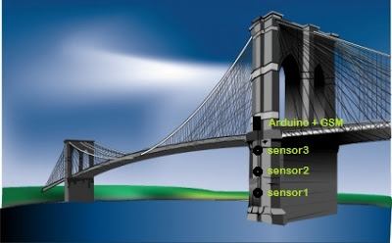river bank and assigned areas as shown:

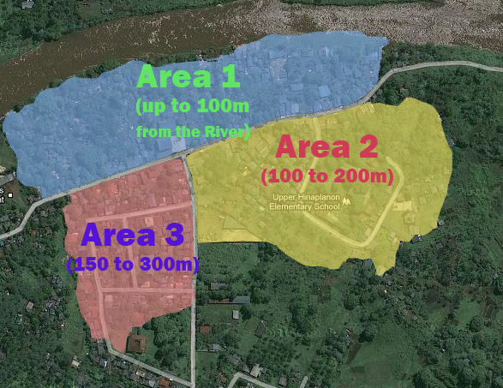

**Figure 3.3 (a)** **and (b)** Prototype design Location

* 1. **Hardware**

**3.3.1 Sensor Unit**

In this project, Cynergy3 RSF53 is used as float switch. In the code, the float switch is set as a default normally close sensor. RSF50 series are compact vertically mounted devices with a single switch point. Mounting is either from the top or bottom. RSF53 is made up of nylon material. Usually, float switches are attached to alarm systems to notify that a certain tank or container is already full, but in this project it was used as a trigger to notify the current water level of the river. Once the sensor is triggered, the Arduino microcontroller commands the GSM Module to send Warning notifications to the assigned Cellular phone destinations.

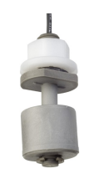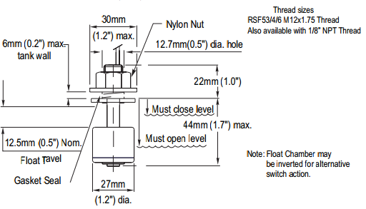

**Figure 3.4** RSF53 Float Switch and Mechanical Dimensions

* + 1. **Arduino Uno Rev3**

The Arduino Uno R3 is a microcontroller board based on a removable, dual-inline-package (DIP) ATmega328 AVR microcontroller. It has 20 digital input/output pins (of which 6 can be used as PWM outputs and 6 can be used as analog inputs). Programs can be loaded on to it from the easy-to-use Arduino computer program.

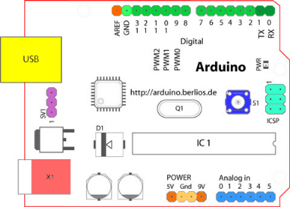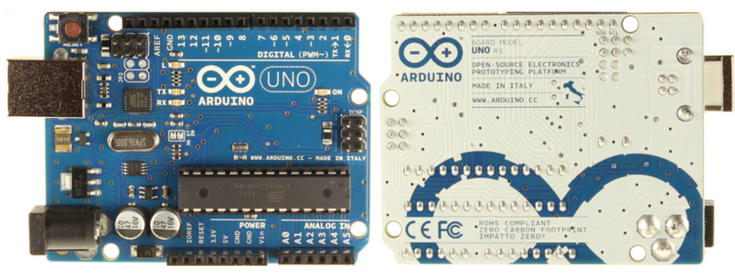

**Figure 3.5** Arduino Uno Rev3

|  |  |
| --- | --- |
| Microcontroller | ATmega328 |
| Operating Voltage | 5V |
| Input Voltage (recommended) | 7-12V |
| Input Voltage (limits) | 6-20V |
| Digital I/O Pins | 14 (of which 6 provide PWM output) |
| Analog Input Pins | 6 |
| DC Current per I/O Pin | 40 mA |
| DC Current for 3.3V Pin | 50 mA |
| Flash Memory | 32 KB (ATmega328) of which 0.5 KB used by bootloader |
| SRAM | 2 KB (ATmega328) |
| EEPROM | 1 KB (ATmega328) |
| Clock Speed | 16 MHz |

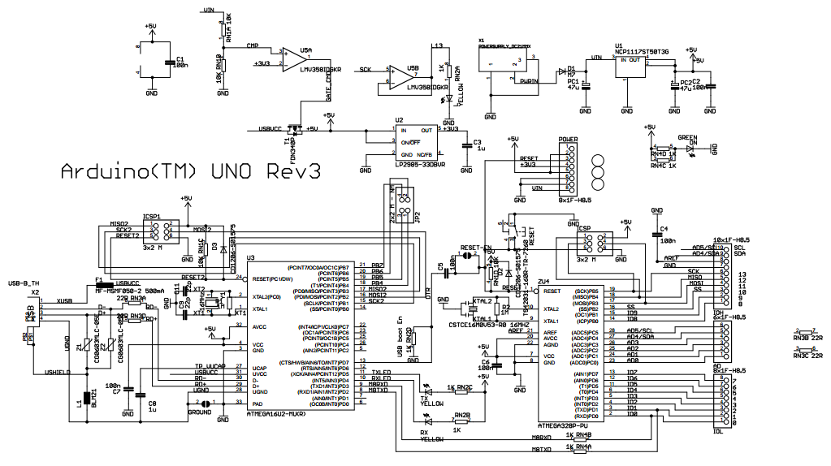

**Figure 3.6** Arduino UNO R3 Full Circuit Guide

* + 1. **Microcontroller Pinning Diagram**

Since the GSM module used is a shield intended for arduino, hence, they have identical pins and just needs to be mounted on the arduino. The figure below shows the pins assigned to connect the sensors, microcontroller and GSM Module.

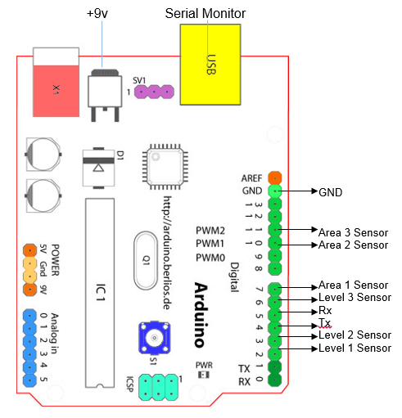

**Figure 3.7** Circuit / Pinning Diagram

**3.3.4 GSM**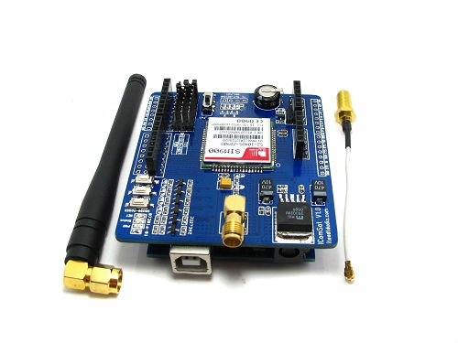

### Figure 3.8 GSM Module

The GPRS (General Packet Radio Service) Shield is a new nonvoice value added service that delivers GSM/GPRS 850/900/1800/1900MHz performance for voice, SMS, Data, and Fax in a small form factor and with low power consumption. It is controlled via AT commands (GSM 07.07 ,07.05 and SIMCOM enhanced AT Commands), and fully compatible with Iteaduino/Arduino and Mega.

### Features

* Quad-Band 850/ 900/ 1800/ 1900 MHz
* GPRS multi-slot class 10/8
* GPRS mobile station class B
* Compliant to GSM phase 2/2+Class 4 (2 W @850/ 900 MHz)
* Class 1 (1 W @ 1800/1900MHz)
* Control via AT commands (GSM 07.07 ,07.05 and SIMCOM enhanced AT Commands)
* Low power consumption: 1.5mA(sleep mode)
* Operation temperature: -40°C to +85 °C

### Hardware

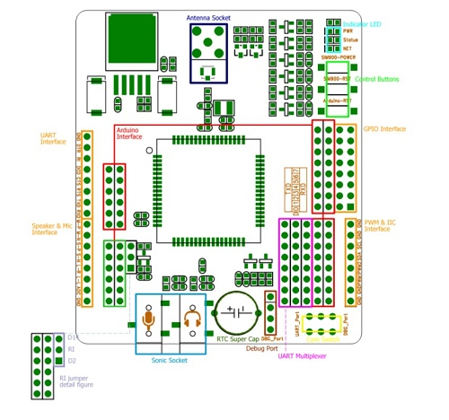

**Figure 3.9** GSM Module Circuit guide

**3.4 Complete Circuit Diagram:**

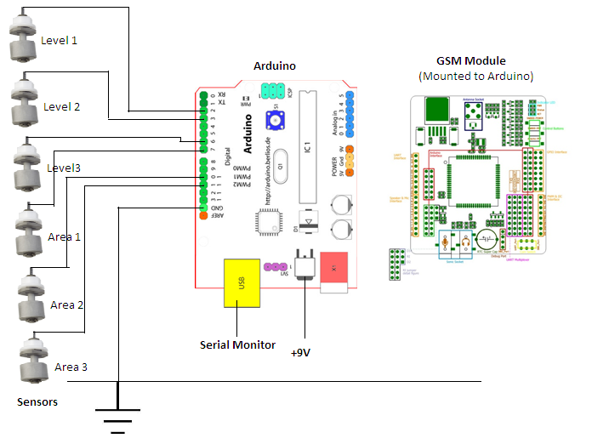

**Figure 3.10** Complete Circuit Diagram

**Operation:**

The operation of the system starts with the triggering of sensors. Level 1 to 3 sensors are setup on the Main River part of the prototype design. In actual conceptualization, this may be placed on the foundation of the bridge or embedded along the river wall. Area 1 to 3 are each placed on the areas part of the prototype setup. In actual conceptualization, this may be placed on 3 flood-prone areas around the river and once the sensor is triggered, it will signify immediate evacuation among residents around the area. The first sensor that will be triggered once the water level of the Main River starts to rise is the Level 1 sensor. Since there is a nylon material on the float switch which is less dense than water, once the water level surpasses the point where the Level 1 float switch is placed, the nylon material will float and closes the switch and once it is detected by the Arduino microcontroller that the switch is already closed, it will enable the sending of warning message to designated mobile phones. For level 1 alert, a message which says “**Warning: FIRST WARNING-level 1**” will be sent to the designated phones and will also be uploaded on the site and social media accounts via the special android phone which should always be connected to the internet. The warning message will appear as a status update on **Facebook** and as a tweet on **Twitter**. Level 1 sensor is the constraint trigger of the system. Other sensors will not be triggered once Level 1 sensor is off.

When the water level continues to rise and reaches the point where the Level 2 sensor is placed, the same operation algorithm is used and another warning messages saying “**SECOND WARNING-level 2”** will be sent to designated mobile phones and uploaded to the social media sites and website. But once the water level, after reaching level 1 will fall and back to the safe level, a warning message saying “**Water at safe level**” will be sent to the designated phones and uploaded to the website and social media accounts. When the water level, after reaching level 2, will fall back to level 1, an alert message saying “**level 2 is clear. Water at level 1**” will be disseminated to assigned mobile phones and same alert message will be uploaded to the social media accounts and the website. On the other hand, when the water level continues to rise after reaching level 2, and reaches level 3, alert messages saying **“LAST WARNING-level 3”** and “**Area 1 will be flooded in 4 mins**” will be sent to the designated mobile phones and uploaded to the website and social media accounts. Level 3 signifies critical level of the water level on the main river and that it will overflow and will flood the residential areas around it anytime. The second alert message of level 3 is the estimated time it takes for the area 1 to reach the critical level based on the uniform water flow we used on the prototype design. In actual conceptualization, this can be replaced by the average time it takes for the water level of Area 1 to reach critical level.

When the water level reaches the critical point of Area 1, alert messages “**Area 1 Flooded!**” and “**Water is now at Area 2**” will be sent to designated phones and will be uploaded to the website and social media accounts. Area 1 is described to be as the most flood-prone area among the three areas and that after area 1 is flooded, the water will be entering Area 2 and after area 2 is already flooded, water will enter Area 3. When the water level continues to rice and reaches the point where the float switch is placed on Area 2, alert messages “**Area 2 Flooded!**” and “**Water is now at Area 3**” will be sent to the assigned mobile phones and uploaded to the website and social media accounts. When the water still continues to rise and reaches the critical point of Area 3, the final point covered by the system, the last alert message “**Area 3 Flooded!**” will be sent to the assigned mobile phones and uploaded to the social media accounts and website.

After some time, when the water level falls and once the float switch for Area 1, the most flood-prone area, is already off, an Alert status saying “**AREA 1 clear!**” will be sent to the assigned phones and will also be uploaded to the social media accounts and will be displayed on the website. On this instance, the water is now concentrated back to the main river.

**3.5 Truth Table for System Operation**

**Input Output**

|  |  |  |
| --- | --- | --- |
| Sensors | LED status on GSM Module | Alert Text/s on Mobile Phone, Website and Social Media Accounts |
| 000000 | Off | None |
| 000000  (from 100000) | On | “Water at safe level” |
| 100000  (from 000000) | On | “FIRST WARNING-level 1” |
| 100000  (from 110000) | On | “Level 2 is clear. Water at level 1” |
| 110000  (from 100000) | On | “SECOND WARNING-level 2” |
| 110000  (from 111000) | On | “Level 3 is clear. Water at level 2” |
| 111000  (from 110000) | On | “LAST WARNING-level 3” and “Area 1 will be flooded in 4 mins” |
| 111000  (from 111100) | On | “AREA 1 clear!!” |
| 111100 | On | “Area 1 Flooded!” and “Water is now at Area 2” |
| 111110 | On | “AREA 2 Flooded!” and “Water is now at Area 3” |
| 111111 | On | “AREA 3 Flooded!” |

**Table 3.1** System Operation Truth Table

The table shows the truth table for the operation of the project system. Each of the six digits on the sensor configuration represents each of the six sensors. The first digit represents Level 1 sensor, second digit for Level 2 sensor, then Level 3, Area 1, Area 2 and Area 3 respectively. These sensors represent the input while the LED status of the GSM Module and Alert Text on Mobile Phone, website and social media accounts represent as the outputs of the input value. For the GSM Modem, there is a Light Emitting Diode or commonly called as LED that indicates that the system is sending an alert message. Once there is a change of status on the sensors, it is detected by the arduino and enables the sending of the alert message from the GSM Modem to the destination phones. While processing the sending of the alert message, there is an LED in the GSM Module that blinks and indicates that the device is sending a message, so in that part of the table, it’s either on or off.

The right portion of the table indicates the messages sent by the GSM Module and then received by the Mobile phones and then uploaded to the website and social media sites. The table provides a clearer view of the corresponding message on each status of the sensors. The complete operation of the system has already been explained on the previous section. However, this table summarizes the possible inputs and its corresponding outputs. Notice that for some inputs, there are two outputs and that the output of some inputs depends on what was the previous status of the sensors. This is possible because of the programmed code in the arduino. A sample code snippet in the arduino that made it possible is this:

**else if (state_new - state_old> 0) // changes in status**

**{**

**goto texting1;**

**}**

**else if (state_new - state_old< 0) // changes in status**

**{**

**goto texting6;**

**}**

In the snippet, it is clear that the new status is compared to the old status. Greater than zero (>0) signifies that the new status is a level higher compared to the old status and less than zero (<0) indicates that the new status is a level lower than the old status. For these two different instances, there are two different outputs represented in the code by “texting1” and “texting 6.” For the complete arduino code of the system, see Appendix.

**3.6 Setup Design:**

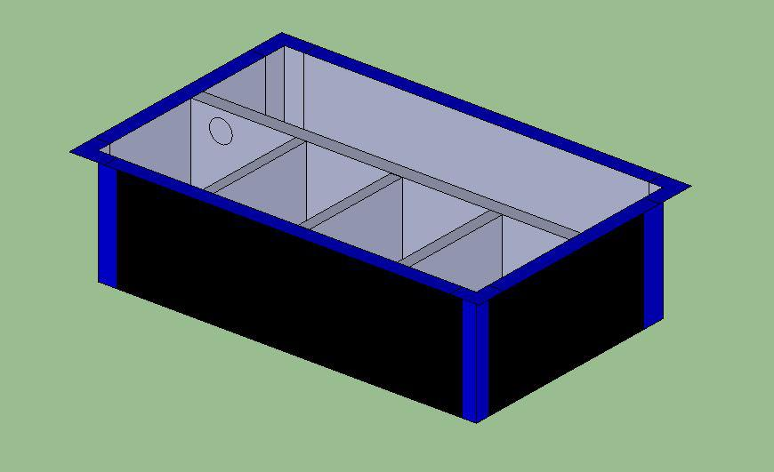

Parts of the Setup:

**Main River**

**Area 1**

**Area 2**

**Area 3**

**Figure 3.11** Setup design

The figure above shows the setup design and its partitions for the setting up of the sensors of the system.

**3.7 Website**

Our assigned live website for this thesis project is [www.mobilewebsitemavens.com/waterlevel](http://www.mobilewebsitemavens.com/waterlevel)

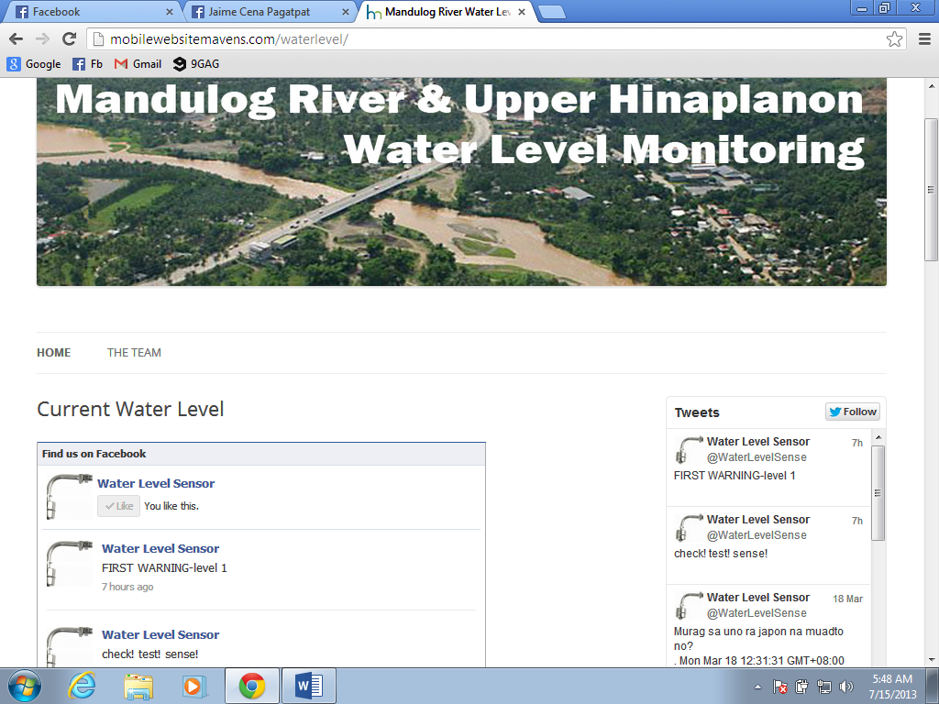

Website Header

Facebook Feed Area Twitter Feed Area

**Figure 3.12** Facebook and Twitter Feeds on the website

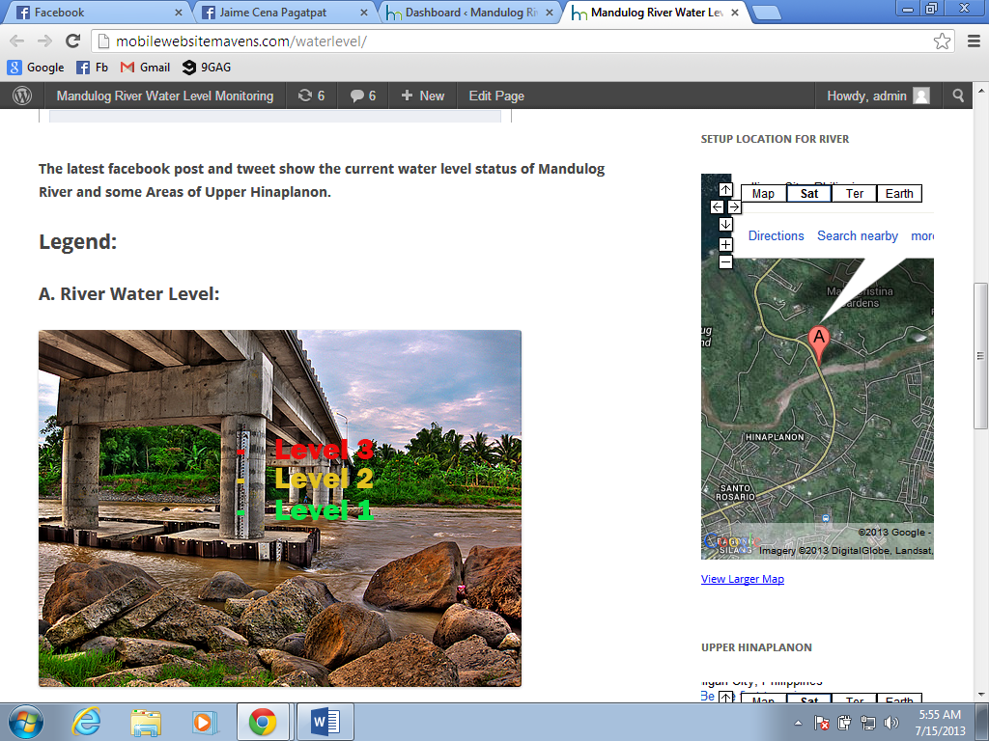

**Figure 3.13** Water Level Legend and Location

In this part of the website, on the left side it shows the legend where our sensors are placed and the indications of water height for the three levels and on the right side is a google map of the location of the bridge.

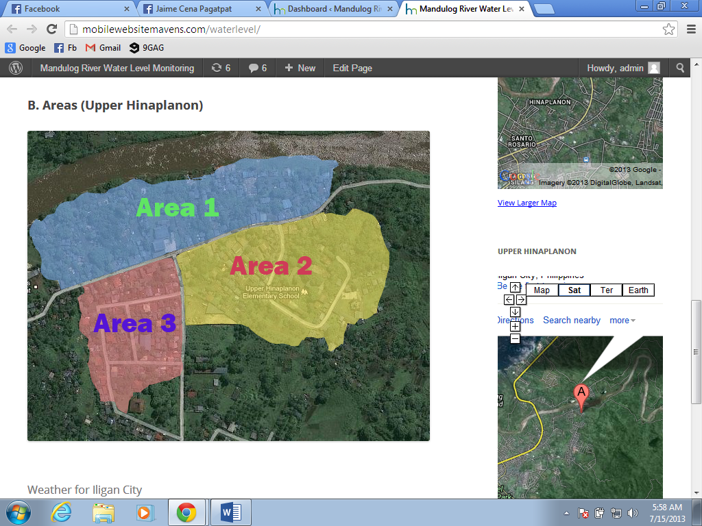

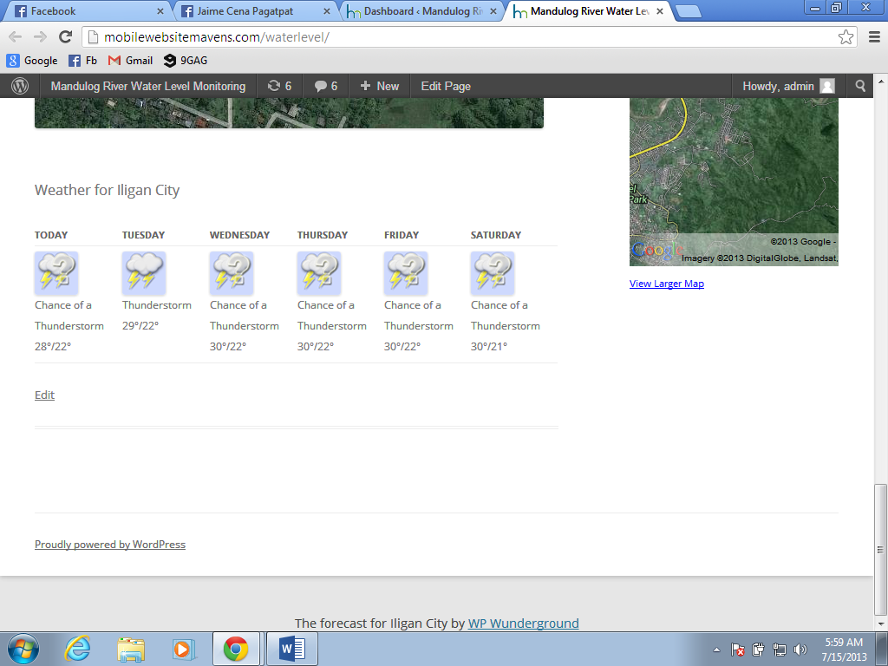

**Figure 3.14** Area Legend, Location and Weather forecast

This image shows the different flood-prone locations in which our sensors will be installed, the right part shows the google map of this community and below is the Weather forecast for Iligan City.

**3.8 Social Media Integration**

**3.8.1 Facebook**

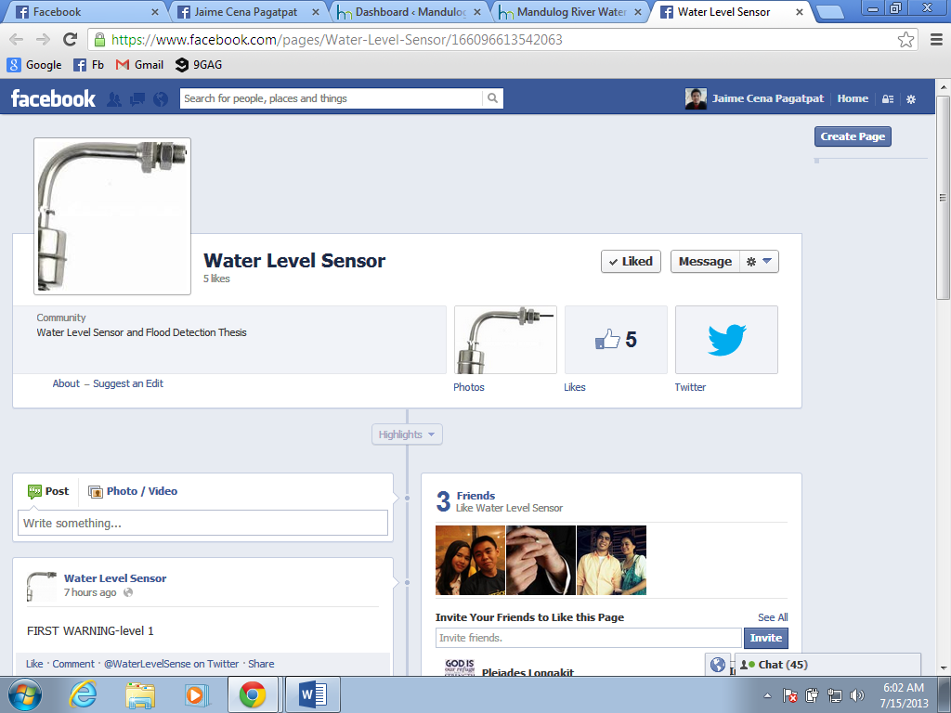

**Figure 3.15** Facebook Page

Facebook page URL: <https://www.facebook.com/pages/Water-Level-Sensor/166096613542063>

Facebook users can also follow our facebook page in order to monitor the current water level status of Mandulog River.

**3.8.2 Twitter**

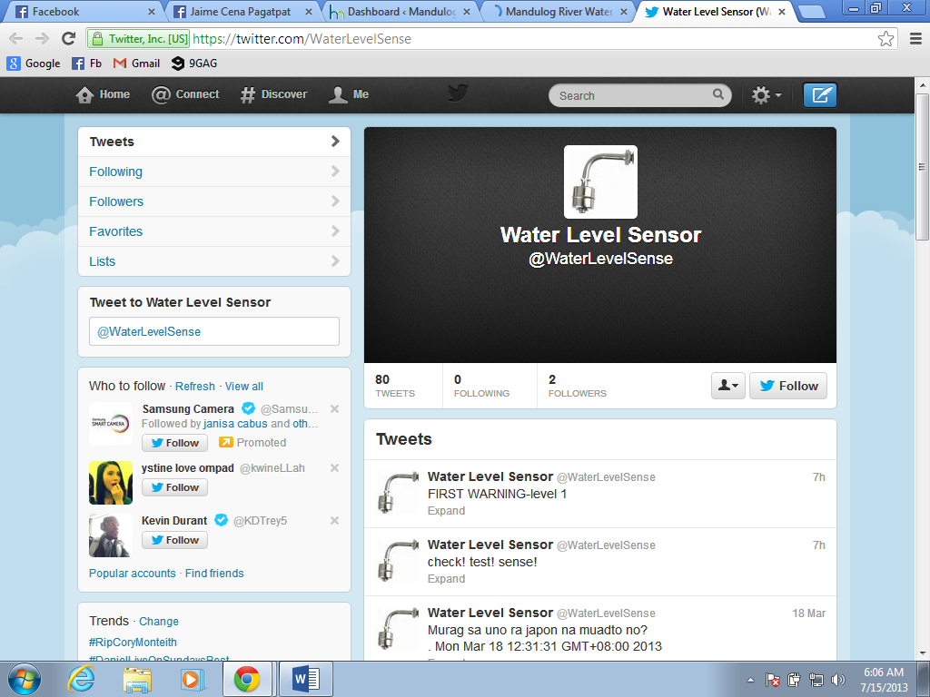

**Figure 3.16** Twitter Page

Twitter Account URL: <https://twitter.com/WaterLevelSense>

Twitter users can also follow our twitter page to be updated on warnings indicated by our system.